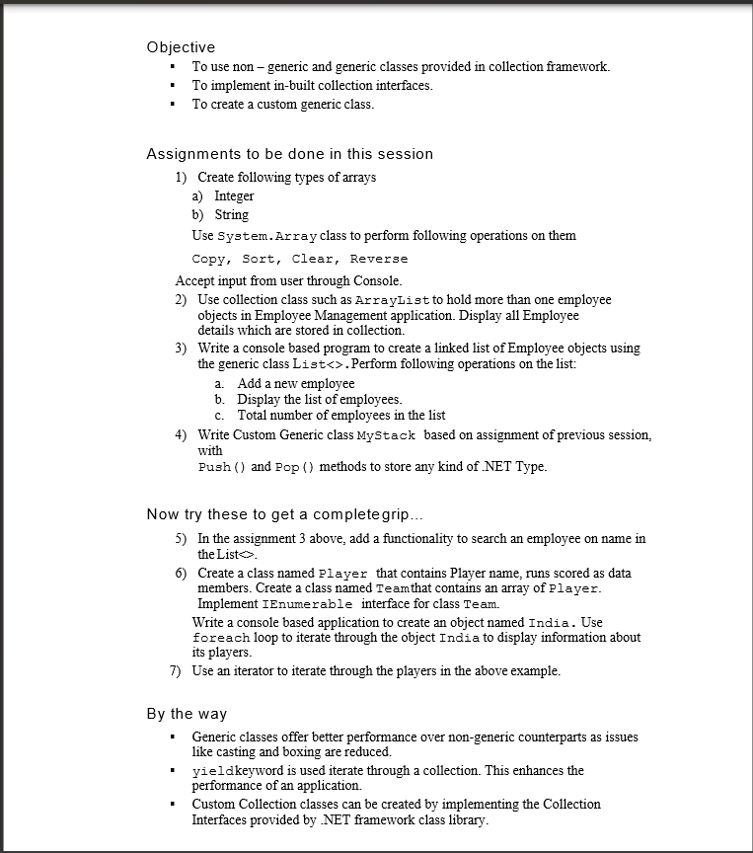

using System;

using System.Collections.Generic;

using System.Linq;

using System.Text;

using System.Threading.Tasks;

namespace SystemArray_Program

{

internal class Program

{

static void Main(string[] args)

{

Console.WriteLine("Enter size of an array");

int size_of_arr = int.Parse(Console.ReadLine());

int[] array = new int[size_of_arr];

string[] string_array = new string[size_of_arr];

Console.WriteLine("Enter int type element in array\n");

for (int i = 0; i < size_of_arr; i++)

{

array[i] = int.Parse(Console.ReadLine());

}

Console.WriteLine("\nOutput before applying any method \n");

foreach (int val in array)

{

Console.Write(val + " ");

}

Console.WriteLine("\n");

int[] array2 = new int[size_of_arr];

Array.Copy(array, array2, size_of_arr);//Copy() Method

Console.WriteLine("After copying one array in array2\n");

foreach (int val in array2)

{

Console.Write(val + " ");

}

Console.WriteLine("\nafter clearing array2\n");

Array.Clear(array2, 0, size_of_arr);//clear method to clear array2

foreach (int val in array2)

{

Console.Write(val + " ");

}

Console.WriteLine();

Array.Reverse(array);//After reversing array

foreach (int val in array)

{

Console.Write(val + " ");

}

Console.WriteLine("\n");

Array.Sort(array);//sorting array

Console.WriteLine("\nAfter Sorting array\n");

foreach (int val in array)

{

Console.Write(val + " ");

}

Console.WriteLine("\nInsert string in string array\n");

for (int i = 0; i < size_of_arr; i++)

{

string_array[i] = Console.ReadLine();

}

Console.WriteLine("Output of String_array before appplying any method\n");

foreach (string ele in string_array)

{

Console.Write(ele + " ");

}

Console.WriteLine("\n");

Array.Reverse(string_array);

Console.WriteLine("After Reversing string array\n");

foreach (string ele in string_array)

{

Console.Write(ele + " ");

}

Console.WriteLine("\n");

Array.Sort(string_array);

Console.WriteLine("\nAfter sorting string_array\n");

foreach (string ele in string_array)

{

Console.Write(ele + " ");

}

Console.WriteLine("\n");

string[] array_string2 = new string[size_of_arr];

Array.Copy(string_array, array_string2, size_of_arr);

Console.WriteLine("\nAfter copying array_string into array_string2\n");

foreach (string ele in array_string2)

{

Console.Write(ele + " ");

}

Console.WriteLine("\nafter clearing\n");

Array.Clear(string_array, 0, size_of_arr);

foreach (string ele in string_array)

{

Console.Write(ele + " ");

}

Console.ReadLine();

}

}

}

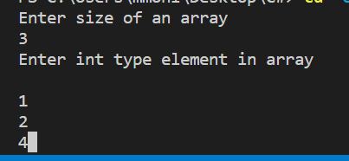

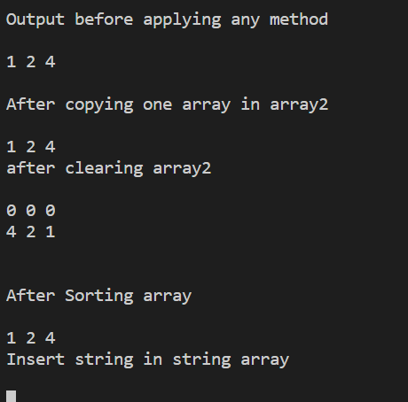

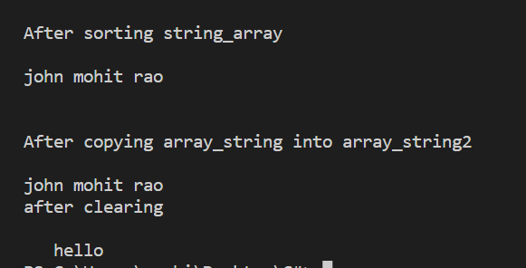

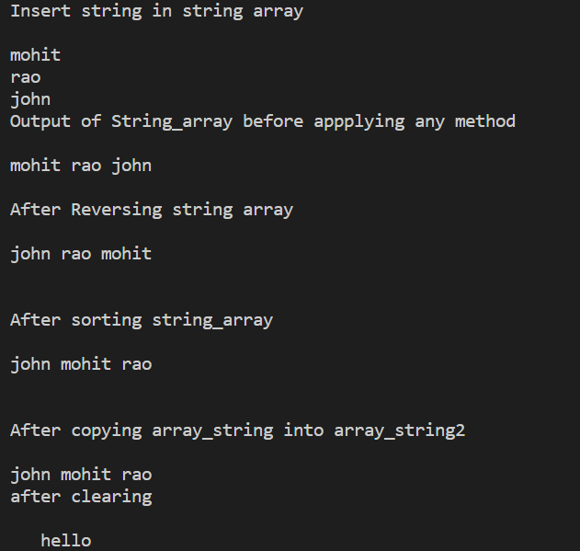

2.

using System;

using System.Collections.Generic;

using System.Linq;

using System.Text;

using System.Threading.Tasks;

using System.Collections;

namespace ArrayList1

{

public class Employee

{

string name;

int emp_id;

double salary;

public Employee(string name, int emp_id, double salary)

{

this.name = name;

this.emp_id = emp_id;

this.salary = salary;

}

public override string ToString()

{

return

String.Format("{0,-10} emp_id : {1,6} salary : {2}", name, emp_id, salary);

}

}

internal class Program

{

static void Main(string[] args)

{

ArrayList emp = new ArrayList();

Console.WriteLine("Add element to the list");

emp.Add(new Employee("Mohit", 022, 234350.89));

emp.Add(new Employee("Priya", 045, 421500.78));

emp.Add(new Employee("Divya", 048, 234560.89));

emp.Add(new Employee("John", 075, 2234010.89));

Console.WriteLine("Employee Details\n");

foreach (Employee empl in emp)

{

Console.WriteLine(" " + empl);

}

Console.ReadLine();

}

}

}

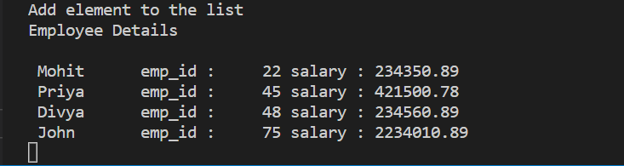

using System;

using System.Collections.Generic;

using System.Linq;

using System.Text;

using System.Threading.Tasks;

namespace Assignment5quet3LinkedList

{

internal class Program

{

static void Main(string[] args)

{

LinkedList<string> employee = new LinkedList<string>();

//Adding a new employee

employee.AddFirst("Sandhya");

employee.AddFirst("Anjali");

employee.AddFirst("Radha");

Console.WriteLine("Display the list of an employee\n");

foreach (string emp in employee)

{

Console.WriteLine(emp + "\n");

}

Console.WriteLine("Total number of employee in the list : " + employee.Count());

Console.WriteLine("\n");

//Searching employee name is it present or not Assignment 5 quetion 5

Console.WriteLine("The employee name Sandhya is present in linked list : " +

employee.Contains("Sandhaya"));

Console.WriteLine("\n");

Console.ReadLine();

}

}

}

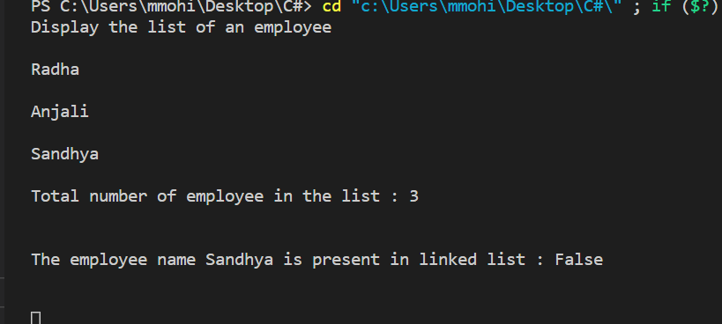

using System;

using System.Collections.Generic;

using System.Linq;

using System.Text;

using System.Threading.Tasks;

using System.Collections;

using static System.Console;

namespace MyStackStoreAnyType

{

internal class Program

{

static void Main(string[] args)

{

Stack st = new Stack();

st.Push("Mohit");

st.Push("Rao");

st.Push(980.89);

st.Push(45);

st.Push('a');

st.Push(225.67f);

st.Push(231348.90D);

foreach (object obj in st)

{

WriteLine(obj);

}

WriteLine("\n");

WriteLine("Popping the element from stack {0}", st.Pop());

ReadLine();

}

}

}

